david perlov’s diary 1973-1983 (Yoman)
Sunday, March 6, 2:00 P.M.

1988, 330 mins.
New York Premiere, with Mira Perlov in person

Made possible with support from the Office of Cultural Affairs, Consulate General of Israel
in New York

2:00 P.M. Parts One & Two (110 mins.)
4:30 P.M. Parts Three & Four (110 mins.)
7:00 P.M. Parts Five & Six (110 mins.)

Written and directed by David Perlov. Produced by Perlov and Mira Perlov. Photographed by David Perlov, Gadi Danzig, Yahin Hirsch, Yosi Sicherman. Edited by Dan Arav, Noga Darewsky, Jacquot Ehrlich, Boaz Leon, Yael Perlov, Shalev Vines. Music by Shem-Tov Levy.

From the Guardian by Michael Kustow, January 5, 2004:

David Perlov was one of the last remaining poets of documentary film. Like Humphrey Jennings, he was a painterly filmmaker, an essayist of the screen, weighing eloquent images against elliptical narration, like the French director Chris Marker.
His 40 years of work were a meditation on the mystery of film, and what it is now fashionable to call the semiotics of sound and silence. Had he not lived and worked for most of his career in Israel, he would have made more, and perhaps been as widely acknowledged as Jean-Luc Godard as a cinematic pioneer. I had the good luck to commission his greatest film, Diary 1973-1982, for Channel 4.
Perlov was born in Brazil. His father was a conjuror, descended from a line of rabbis. “When my father died,” Perlov told me, “he had a minyan (the Hebrew word for a quorum) of magicians to consecrate his tombstone.” He was brought up by a black “mama”, who swathed him in songs and embraces, planting a Brazilian mixture of sensuality, formal religion and Indian atavism.
Like many filmmakers of his generation, Perlov made a beeline for Paris at the age of 22, earning a pittance —and a free film education—as projectionist at the new-born Cinematheque. He fed his eyes on the city's great paintings, and his mind on its postwar creative effervescence. He made his first short film, based on drawings from an old children's book. But he was still seeking the right place for himself as a filmmaker.
In 1958, he emigrated to Israel with his Brazilian wife Mira. I asked him what he felt himself to be most, Brazilian or Israeli. “For nature, Brazil; Israel for ethics,” he said. “In Tel Aviv, I feel the human presence more strongly. Because it's such an ugly city, people stand out from it more clearly. In Brazil, they melt into nature.”
Television had not yet reached Israel, and Perlov made short films for a variety of public agencies. In Jerusalem (1963) was a landmark; it eschewed official pieties and evoked a haunting, offbeat picture of that city's battered magnificence, reminiscent of Jean Vigo's A Propos de Nice.
Perlov defended his lyrical style against Zionist committees that did not much care about the images but quibbled about every syllable of the soundtrack. “Jews don't watch films with their eyes,” he often said, “but with their ears.” He also made two features, The Pill (1968), scripted by the playwright Nissim Aloni, and a dramatised biography of David Ben Gurion (1969).
But Perlov's fastidious, reflective personality did not fit well with commercial film production or state propaganda and, in 1973, he bought a cheap camera and started filming from his Tel Aviv apartment window, thus beginning his Proust-like masterpiece Diary. To subsidise the work, he taught at Tel Aviv University.
Diary is Perlov's quiet river, streaming through wars, from the 1973 Yom Kippur near-disaster to the disorderly withdrawal from Lebanon in 1982, travel—back to Paris and Brazil—and reflections on painting, photography, family and distant friends, ageing and neighbourhood. He made the balconies he could see from his window, the street-corner at his front door, into microcosms of the tremors shaking Israel.
Diary is finally about the threads that bind a man to his country of citizenship, his countries of belonging. Perlov's deep-voiced narration ties together these fragments of contemporary Israel, for by ploughing into himself and his life he painted his country's fate. “I suppose Diary is trying to remind people of the ordinary humanness of life,” he told me in 1976. “So much here has become ideological and political.”
I last saw Perlov just under a year ago. Liran Atzmor, a young producer, had set him up in a light, spacious basement studio, which he festooned with fine art postcards. There, he was slowly and punctiliously completing his final film, My Stills 1952-2002, made almost entirely of still photographs, each image imbued with a weight of contexts, sadness, memory and moments of arrested beauty.
His resonant voice—the dissenting, uneasy voice of a Jew who thought with his eyes and remained displaced in his heart—went on asking questions to the end.
Excerpt from “The Camera as Pen and Brush” by Uri Klein of Haaretz Magazine, May 2, 1999:
In 1973 I encountered Perlov in his role as a lecturer in the film and television department at Tel Aviv University. The Yom Kippur War had just ended. At the start of the war, Perlov began filming what would become his Diary. It happened almost by chance. On that Yom Kippur, he focused his camera on the window of his apartment in order to capture the familiar and the routine. He discovered that the familiar had been transmuted into the different, and the routine into the exceptional. Here was the first connection in Diary between the private and the national, between the view from inside and the reality revealed outside.

Perlov is a consummate filmmaker, but he is also a consummate painter and poet – and all these elements are channeled into his work and render it consummate cinema. Few works of art are capable of providing the pleasure involved in being exposed to such a direct and immediate connection between thought and creation.

Perlov, more than any other filmmaker, demarcated the boundaries of Israeli cinema and defined its goals. As he did so, he produced a richly beautiful oeuvre, marvelously lucid and charged with rare emotional power. He was able to transform the biography of the self into the biography of the other, and to transmute his self-portrait of the viewer. His cinema then, is the identity card of us all.

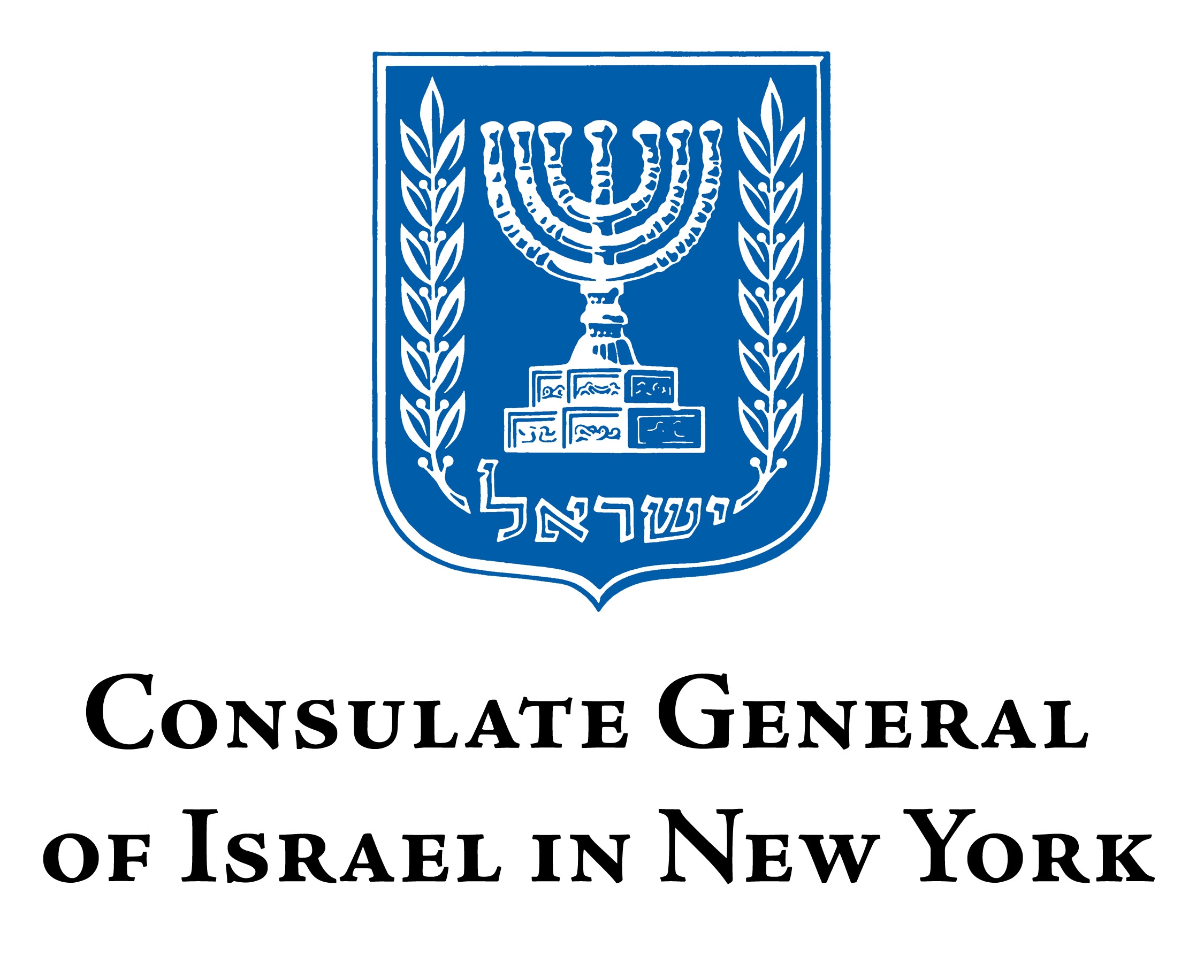

Museum of the Moving Image is grateful for the generous support of numerous corporations, foundations, and individuals. The Museum is housed in a building owned by the City of New York and receives significant support from the following public agencies: the New York City Department of Cultural Affairs; New York City Economic Development Corporation; New York State Council on the Arts; Institute of Museum and Library Services; National Endowment for the Humanities; National Endowment for the Arts; Natural Heritage Trust (administered by the New York State Office of Parks, Recreation and Historic Preservation).

Copyright © 2011, Museum of the Moving Image

