Fashion in film festival:
birds of paradise
April 15—4, 2011

Guest curator, Marketa Uhlirova

fashions of 1934
Sunday, April 24, 7:00 p.m.

1934, 78 mins. New 35mm print courtesy of the Packard Humanities Institute.
Directed by William Dieterle. Written by F. Hugh Herbert and Carl Erickson. Based on the story The Fashion Plate by Harry Collins and Warren Duff. Photographed by William Rees. Edited by Jack Killifer. Costume Design by Orry-Kelly. Art Direction by Jack Okey and Willy Pogany.
Principal cast: William Powell (as Sherwood Nash), Bette Davis (Lynn Mason), Frank McHugh (Snap), Hugh Herbert (Joe Ward), Verree Teasdale (Grand Duchess Alix), Reginald Owen (Oscar Baroque), Henry O’Neill (Duryea).

Review by Mordaunt Hall of The New York Times, January 20, 1934:
It is a brisk show that has come to the screen of the Hollywood Theatre under the tag of Fashions of 1934. The story is lively, the gowns are interesting and the Busby Berkeley spectacles with Hollywood dancing girls are impressive. Instead of the stereotyped narrative about the enchantress who becomes an overnight queen of the Broadway stage, there is in this film something original, for it is concerned with a scamp who either copies the latest Parisian sartorial creations or invents others and disposes of them in America as the latest models from various Rue de la Paix concerns.
William Powell, who never resorts to half-way measures in the matter of his personations, appearing either as a clever criminologist or a clever crook, this time chooses to be an amiable swindler, known as Sherwood Nash. He is never downhearted, not even when the telephones are being stripped from the walls of his offices and the furniture being carried out because he is without funds. An innocent word may be dropped which gives him an idea and it results in several thousand dollars coming his way. He outwits dressmakers who have bought Paris models, even to tempting them to send him abroad on a munificent salary when at the moment he cannot boast of possessing half a dollar.
His nimble mind is too much even for Oscar Baroque, a Parisian gown designer, and another of his dupes is Joe Ward, the bibulous owner of an ostrich farm. Matters are made easy for him in his encounter with Baroque, for the latter happens to be infatuated with a pseudo-Grand Duchess, who is really of the Hoboken (N. J.) nobility. She is, however, very attractive, being acted by the capable Verree Teasdale, and not for worlds would Baroque like Paris to know that the woman who has accompanied him to theatres, the Opéra and restaurants is naught but an American gold-digger.
Reginald Owen appears to advantage as Baroque. The comedy is heightened by Frank McHugh, who enjoys Nash's confidence. Bette Davis portrays Lynn Mason, a loyal lieutenant of Nash's, who wishes that he would abandon his reckless mode of living. Hugh Herbert is quite droll as Ward, who, with Nash's astute assistance, hopes to corner the ostrich-feather market. Mr. Powell never falters in his fast-moving interpretation of the ever-confident Nash.
William Dieterle, that expert director who has been responsible for several imaginative pictures, does well by this particular production, the tale of which is bound to remind spectators of Get-Rich-Quick Wallingford's notable exploits.

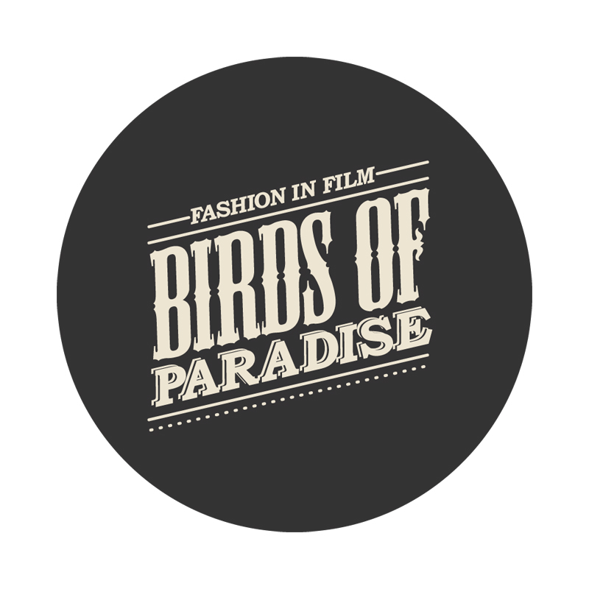

Fashion in Film is an exhibition, research, and education project based at Central Saint Martins College of Art and Design, University of the Arts London. Birds of Paradise, Fashion in Film’s second collaboration with Museum of the Moving Image, was organized in partnership with Yale University, the Center for the Humanities, and the Graduate Center at the City University of New York. The program was curated by Marketa Uhlirova, with assistance from Ronald Grogg, Stuart Comer, Eugenia Paulicolli, and Inga Fraser, and organized for Moving Image by Chief Curator David Schwartz and Assistant Curator of Film Rachael Rakes.

Museum of the Moving Image is grateful for the generous support of numerous corporations, foundations, and individuals. The Museum is housed in a building owned by the City of New York and receives significant support from the following public agencies: the New York City Department of Cultural Affairs; New York City Economic Development Corporation; New York State Council on the Arts; Institute of Museum and Library Services; National Endowment for the Humanities; National Endowment for the Arts; Natural Heritage Trust (administered by the New York State Office of Parks, Recreation and Historic Preservation).

Copyright © 2011, Museum of the Moving Image

