FASHION IN FILM FESTIVAL: BIRDS OF PARADISE
April 15 – April 24, 2011
Guest curator: Marketa Uhlirova

jack smith’s normal love and underground opulence
Friday, April 15, 7:00 P. M.
Introduced by Marketa Uhlirova and David Schwartz. Live music by Makia Matsumara.

Marketa Uhlirova is Senior Research Fellow at Central Saint Martins College, University of the Arts London, and Director/Curator of the Fashion in Film Festival where she oversees all of its programming. She is also the editor of Fashion in Film’s publications, including If Looks Could Kill: Cinema’s Images of Fashion, Crime and Violence (Koenig Books and FFF, 2008) and the forthcoming Birds of Paradise: Costume as Cinematic Spectacle (Koenig Books and FFF, 2011). She has contributed articles on fashion and art to publications including Art Monthly and FashionTheory.

Makia Matsumura is an award-winning composer, pianist and silent film accompanist based in New York. She has accompanied screenings at the Lincoln Center, the Pordenone Silent Film Festival and the National Film Center at the National Museum of Modern Art, Tokyo. She has also composed orchestral music, and created new soundtracks for film and television.

David Schwartz is Chief Curator at the Museum of the Moving Image, and editor-at-large of the Museum’s online publication, Moving Image Source. He has organized a wide range of retrospectives covering avant-garde cinema, classic Hollywood, contemporary independent film, animation, documentary, world cinema, and much more, and he is the regular moderator for the Museum’s Pinewood Dialogues, an ongoing series of conversations with key creative figures in film, television, and digital media.

TIT FOR TAT (LA PEINE DU TALION)
Gaston Velle, 1906, 5 mins. Silent with live music. Digital Projection: Lobster Films, Paris.
Gloriously winged insects seek revenge for the injustices brought about by the popular practice of lepidoptery: the catching of butterflies and moths for the purpose of scientific observation. Velle’s richly colored film is one of the finest examples of its kind.

METEMPSYCHOSIS (MÉTEMPSYCOSE)
Segundo de Chomón, 1907, 3 mins. Silent with live music. 35mm print: British Film Institute.

The special effects pioneer Segundo de Chomón reinterprets for the camera a famous stage illusion that featured a metamorphosis from one object (or
person) into another. A statue turns into a butterfly fairy who performs a number of ravishing costume transformations.

PUCE MOMENT
Kenneth Anger with Yvonne Marquis, 1949, 6 mins. 16 mm print: Canyon Cinema.

Puce Moment is a fragment filmed in 1949 and later edited by Anger himself into a stand-alone piece. It was conceived as the feature-length film
Puce Women, and was to be Anger’s tribute to the mythological Hollywood of the Jazz Age and the perversely luxurious tastes and lifestyles of
female sirens such as Mae Murray, Barbara La Marr, Marion Davies, and Gloria Swanson (some of whom are described in his exposé Hollywood
Babylon). Referring to the purple-green iridescent color of 1920s flapper gowns, Anger’s mood sketch evokes the archetypal moment of a film star’s dressing up. It is a dizzying parade of vintage gowns: their beading, sequins and embroidery shimmer aggressively in front of the camera, taking up entire film frames.

THE PEARL FISHER (LE PÊCHEUR DE PERLES)
Ferdinand Zecca, 1907, 12 mins. 35mm print : Lobster Films.

A deep-sea diver encounters strange and marvelous creatures in an underwater kingdom. The final apotheosis boasts remarkable sets
festooned with strings of pearls that recall Méliès’s Orientalist décors for The Palace of Arabian Nights (1905).

NORMAL LOVE
Jack Smith, 1963, 120 mins. 16 mm print courtesy of Gladstone Gallery, New York.

Though Jack Smith never quite completed Normal Love (1963), what he left behind maintains a consistent level of intensity, its weirdly costumed characters cavorting before the camera in role-playing more twisted than the word “drag” could ever convey. Mostly filmed the year Smith’s orgy-comedy Flaming Creatures became a famous obscenity case, Normal Love is a kind of lyrical sequel, replacing the earlier film’s bleached-out black and white with lush color and its urban claustrophobia with rural locales outside New York City. Over the years Smith showed Normal Love in various versions; the present film was assembled using notes from actual screenings and records he’s known to have played with it. His cast of “creatures,” including Mario Montez and Tiny Tim, perform in a series of disjointed sequences that oscillate between trancelike impersonation and utterly reflexive self-parody: a mermaid in a tub, for example, is larger than life yet totally ridiculous, her tail phonier than the worst B-movie costume. Smith’s gender-[bending] visions, more radical than mainstream concepts of drag, conflate dress-up with striptease, ludicrous acting with a sure belief that one can become one’s costume. His visual style is a dense and demented re-creation of von Sternberg, the smallest fashion accessory a radiant surface as camera and character—and character and costume—move in a coordinated ballet at once graceful and spastic.
- Fred Camper, The Chicago Reader, February 26, 1998

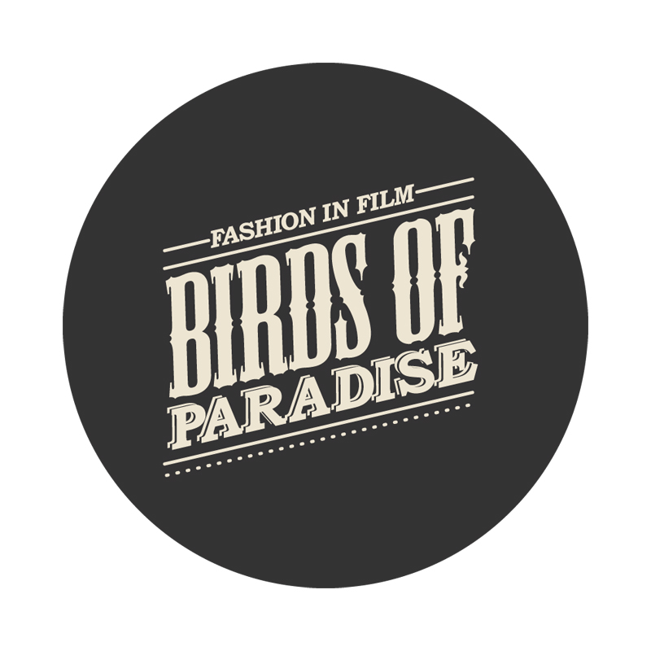

Fashion in Film is an exhibition, research, and education project based at Central Saint Martins College of Art and Design, University of the Arts London. Birds of Paradise, Fashion in Film’s second collaboration with Museum of the Moving Image, was organized in partnership with Yale University, the Center for the Humanities, and the Graduate Center at the City University of New York. The program was curated by Marketa Uhlirova, with assistance from Ronald Grogg, Stuart Comer, Eugenia Paulicolli, and Inga Fraser, and organized for Moving Image by Chief Curator David Schwartz.

Museum of the Moving Image is grateful for the generous support of numerous corporations, foundations, and individuals. The Museum is housed in a building owned by the City of New York and receives significant support from the following public agencies: the New York City Department of Cultural Affairs; New York City Economic Development Corporation; New York State Council on the Arts; Institute of Museum and Library Services; National Endowment for the Humanities; National Endowment for the Arts; Natural Heritage Trust (administered by the New York State Office of Parks, Recreation and Historic Preservation).

Copyright © 2011, Museum of the Moving Image

